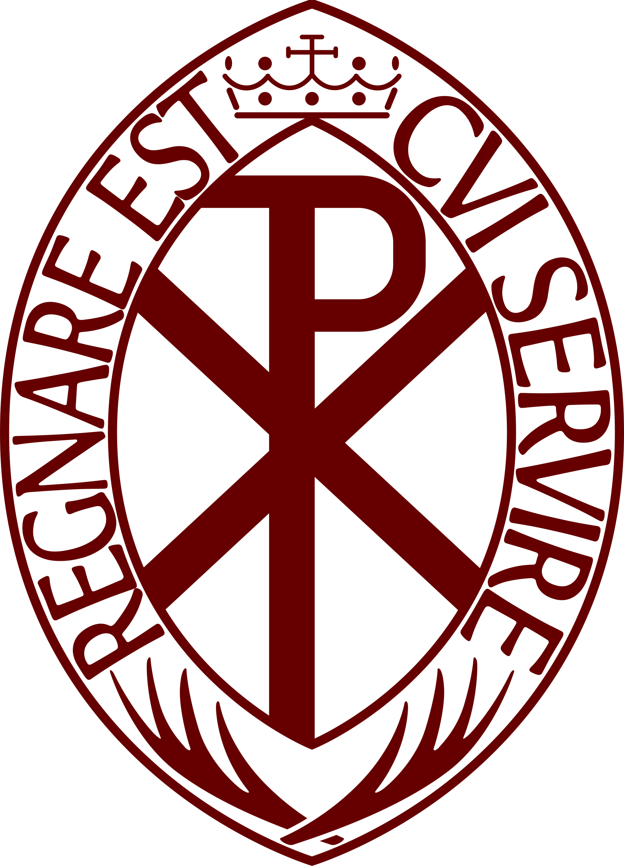

CONSENT FORM – USE OF VIDEO/PHOTOGRAPHIC MATERIAL
The Archconfraternity (Guild) of St Stephen is committed to ensuring that information we hold about individuals is properly and securely managed in accordance with legal requirements on data protection, direct marketing, and our responsibility for safeguarding.
Please complete this form if you would like to give your consent to the Guild of St Stephen holding and processing your personal data for the purposes listed below.
My name is (the person filling out the form, “you”):
………………………………………………………………………………………………..……………………………………………………………..
If you are filling out this form for a child or another individual unable to provide informed consent, then please complete Sections 1 and 2. If you are filling out this form on your own behalf, please complete Section 2 only.

Section 1
Name of individual who you are providing consent for (named individual):
……………………………………………………………………………………………..………………………………………………………………..
Reason for filling out the form on behalf of the named individual:
- The named individual is a child who would not understand what providing consent means.

- The named individual does not have sufficient understanding of consent to provide it for themselves.
Relationship to named individual you are providing consent for:
- Parent/carer/guardian

- Other (please write) ……………………………………….……………………………………….………………………………

Section 2
When filling in this consent form, please understand the following:
- If you are filling this form on your own behalf the (you, your, I, me) relates to the person filling out the form. Where it is being filled out on behalf of named individual the (you, your, I, me) relates to that named individual.
- You do not have to consent to any of the purposes listed.
- I understand and agree that images on the Internet can be viewed throughout the world and not just in the United Kingdom and that some overseas countries may not provide the same level of protection to the rights of individuals as UK legislation provides.
- I understand and agree that once a photograph or video is published it is then in the public domain for an indeterminate period, and that any subsequent withdrawal of consent will not result in the unavailability of any image/video which is already in the public domain, only the use of that image/video by the Guild of St Stephen.
- I consent to the Guild of St Stephen using photographs and/or video recordings of me or (named individual) taken by the Guild or by persons or organisations authorised on behalf of the Guild for the purposes of internally or externally promoting the work of the Guild. These images could be used in any media (existing or later created or made available) including print and digital media formats such as print publications, websites, posters, or social media.
Signed: .……………………………………………………………………………………………………………………………………………….
Date: …………………..……………………………………………………………………………………………………………………………

Withdrawing Consent
You can withdraw or change your consent at any time by contacting The Archconfraternity of St Stephen by e-mail at: safeguarding@guildofststephen.org
Please note that all processing of your personal data will cease once you have withdrawn consent, other than where this is required or permitted by law. This will not affect any personal data that has already been processed prior to that point.
Unless consent is withdrawn, this consent form will be valid for 2 years in the case of a self-declaration. Forms filled out on behalf of a named individual will need to be renewed every 12 months and an assessment made as to whether the named individual can provide their own consent.

