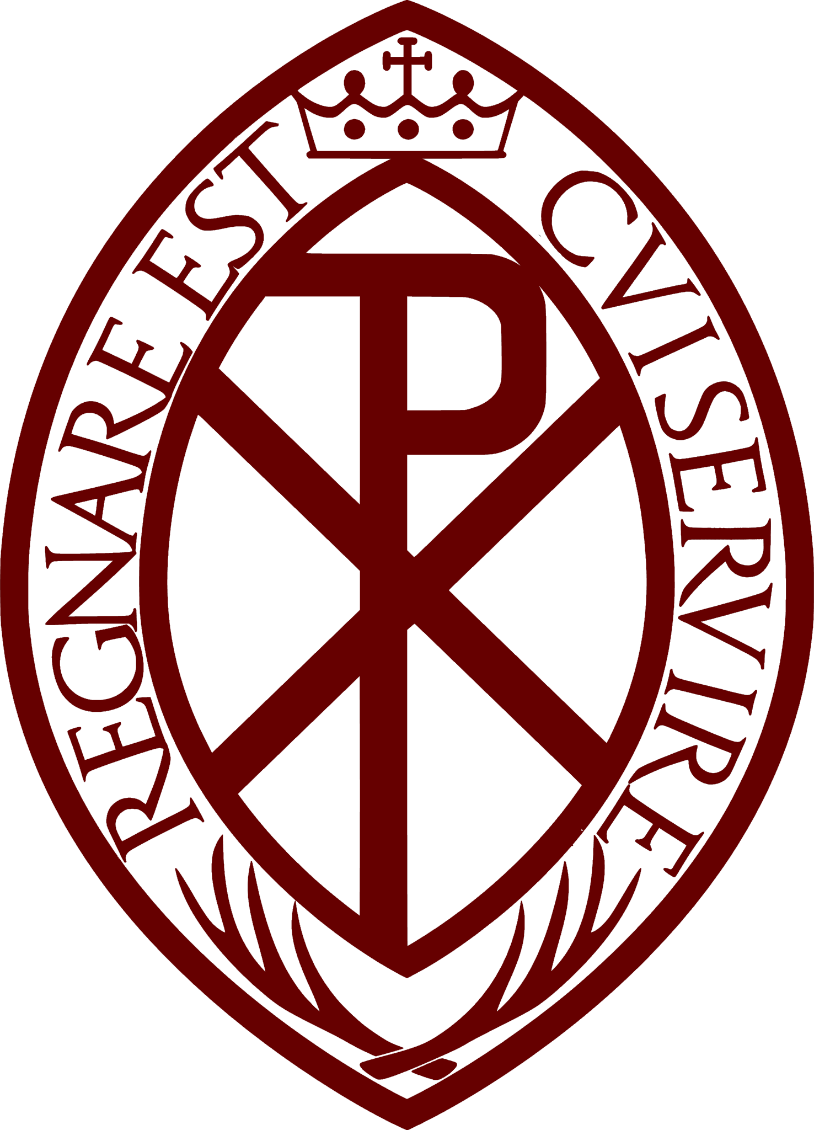

ANNUAL GENERAL MEETING
ARCHCONFRATERNITY OF ST STEPHEN
SATURDAY 5th NOVEMBER 2022, 1.30pm
ST ALOYSIUS PARISH HALL, SOMERS TOWN, LONDON & MICROSOFT TEAMS

AGENDA
- Opening Prayer

- Welcome & Apologies for Absence

- Approval of the Minutes of the Last Meeting
  - Annual General Meeting – 27th November 2021
  - Matters Arising from the Minutes

- Year Ending 30th June 2022 Reports
  - Central Council Report
  - Approval of Accounts & Balance Sheet (2021-2022)
  - Appointment of “Examiner” of the Accounts (2022-2023)

- National Directors Address

- Election of Members to the Central Council

- Announcements & News

- Honorary Presidents Address

- Keynote Speaker Rev Cannon PJ Smith (Portsmouth Diocesan Director & Chair of CYMFed)

- AOB

- Closing Prayer & Guild Hymn

The Guild Hymn (One verse only)

Holy Stephen, Christ’s dear martyr.
First to shed thy blood for him.
What bright glory now surrounds thee.
Glory which no time can dim.
O that we could share that glory.
Give for him our life and blood.
Let us praise thy noble story.
Told with life’s own crimson flood.

