Service Awards

 | Bronze
Awarded on enrollment into the Guild of St Stephen by the Parish Priest on the recommendation of the Parish M.C..

Servers must show that they are reverent in their actions, come to Mass regularly and understand the Mass.
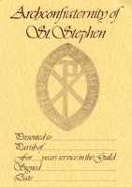 | Certificate of Merit
 | The Certificate of Merit, awarded by the Parish Priest after 5 continuous years of serving.
 | Silver
 | Awarded by the Diocese Director of the Guild on the recommendation of the Parish Priest for 10 years of continuous service to the church as an enrolled member of the Guild.
 | Silver Medal of Merit
 | Awarded by the Diocese Director of the Guild after 20 years of serving (not all that time as a member of the Guild), on the recommendation of the Parish Priest.
 | Gold
 | Awarded by the Guild Central Council on the recommendation of the Parish Priest for for 50 years of continuous service as an enrolled member of the Guild.
 | Gold Medal of Merit
 | Awarded by the Guild Central Council on the recommendation of the Parish Priest after 50 years of serving (not all that time as a member of the Guild).

