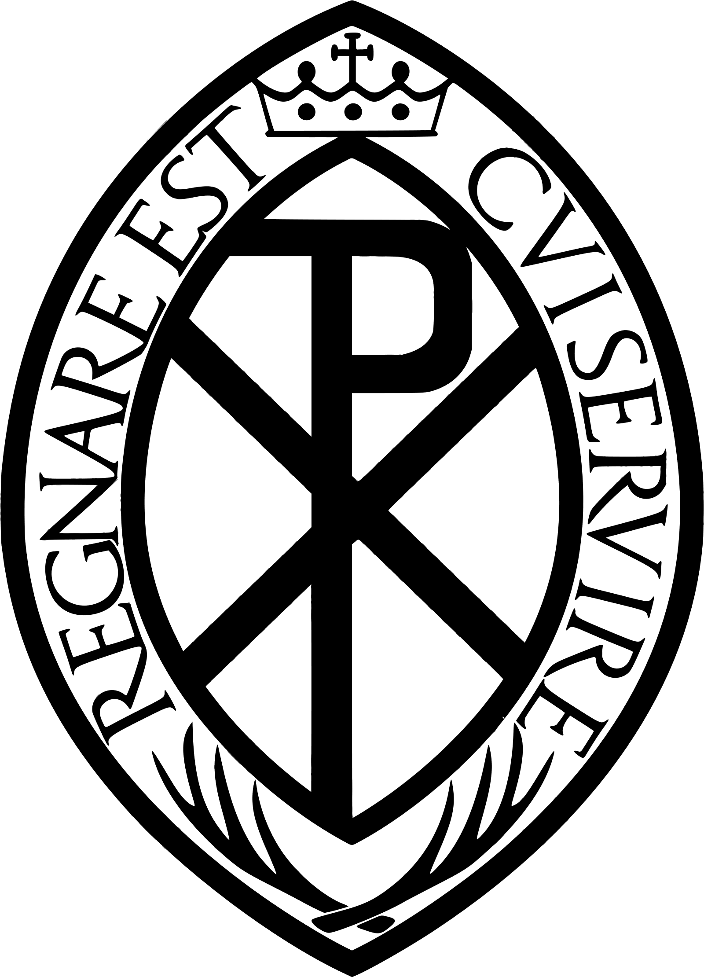
THE SACRED PASCHAL TRIDUUM
MASS OF THE LORD’S SUPPER
Maundy Thursday

The following is a template for M.C.’s and organisers to adapt as they see fit to
help plan an Ordinary Form celebration of the Mass of the Lord’s Supper on Maundy Thursday.

Before Mass
- Liturgical colour is White
- Altar of Repose is prepared as required
- The Tabernacle should be entirely empty and open
- Extinguish the Sanctuary Lamp
- Holy Oils prepared
- Enough hosts to be consecrated at this Mass to also cover communion on Good Friday.
- Bowl, jug and towels for washing of feet.
- Extra items for clergy to wash hands after feet washing
- Humeral Veil
- Bells for Gloria only

Entrance Procession
- Procession forms as normal and Mass begins in the usual way. | Thurible
 | Boat
 | Cross
 | Candles

Reception of the Holy Oils
- Servers with priest for reception of Holy Oils. | Holy Oils

Penitential Act

The Gloria
- The Gloria is sung while bells are rung.  - When it is finished, Bells remain silent until the Gloria of the Easter Vigil.  - Move Bells out of the way so they are not rung again. | Bells

Collect
Let us Pray… Amen.  Sit | Missal for Collect

Liturgy of the Word

First Reading

Psalm

Second Reading
Gospel | Thurible | As above
Stand.  - Gospel Procession as normal. | Boat | As above
 | Candles (2) | As above

Homily

The Washing of Feet
When the Homily has ended and after a brief moment of silence:
- Priest removes Chasuble, server to assist | Chasuble
- 12 chairs put out for those having their feet washed  - Servers to Sanctuary steps (pulpit side) to assist with feet washing, follow priest as he washes feet. Once finished servers dispose of the items. | Chairs (12)
 | Towels
 | Water Jugs
 | Bowl
Once all have had their feet washed and have returned to places:
- 12 servers from before remove the chairs | Chairs | As Above
- Priest washes hands  - Priest puts chasuble back on and returns to chair. | Wash hands
 | Chasuble | As Above
No Creed.
Stand
Universal Prayer (Bidding Prayers) | Folder with prayers bearer

The Liturgy of the Eucharist

Offertory
Sit  - Servers lead the Offertory Procession in the usual manner | Offertory Procession (2)
- Set Altar as normal | Set Altar
Mass continues as normal, no Gongs/Bells although a Crotalus (Rattle) may be used instead if available.

Communion
- Clear Altar in the usual way | Clear Altar
- Prepare 2 Thuribles and bring to Sanctuary | Thuribles (2)
- Prepare Altar of Repose | Altar of Repose

Prayer after Communion
Stand  Let us Pray… Amen. | Post Communion Prayer Missal

The Transfer of the Most Blessed Sacrament
Immediately after the Prayer after Communion (there is no dismissal):
- 2 Thuribles, Boat & server with the Humeral Veil wait  - Cross Bearer retrieves Processional Cross  - Candle Bearers take Candles  - The above lead all other servers away to form procession line | Thuribles (2)
 | Boat | As Above
 | Cross | As Above
 | Candles (2) | As Above
- Priest puts incense in the Thuribles while standing, blesses it and then, kneeling, incenses the Blessed Sacrament still on the Altar.  - Thurifers and Boat bearer join other servers in Aisle at the rear of the procession. | Thurible | As Above
 | Boat | As Above
- Priest puts on the humeral veil, he rises, takes the Blessed Sacrament, and covers it with the ends of the veil.  - Humeral Veil server joins other servers in Aisle. | Humeral Veil | As above

Procession
- Priest leaves Sanctuary carrying the Blessed Sacrament

- Canopy / Ombellino brought across and covers the priest | Canopy / Ombellino
- Procession starts, Cross Bearer leads to Altar of Repose VERY SLOWLY.

- Thuribles alternating swing in front of the Priest / Blessed Sacrament

Altar of Repose
On arrival at Altar of Repose:  - Candles placed on Altar  - Thurifers and boat stand near priest  - Cross bearer stands near Altar  - Humeral Veil removed | Humeral Veil | As above
Kneel
- Priest incenses Blessed Sacrament

- Pause for period of silence

Stand

- Cross bearer leads all to back to the Sacristy in silence.

