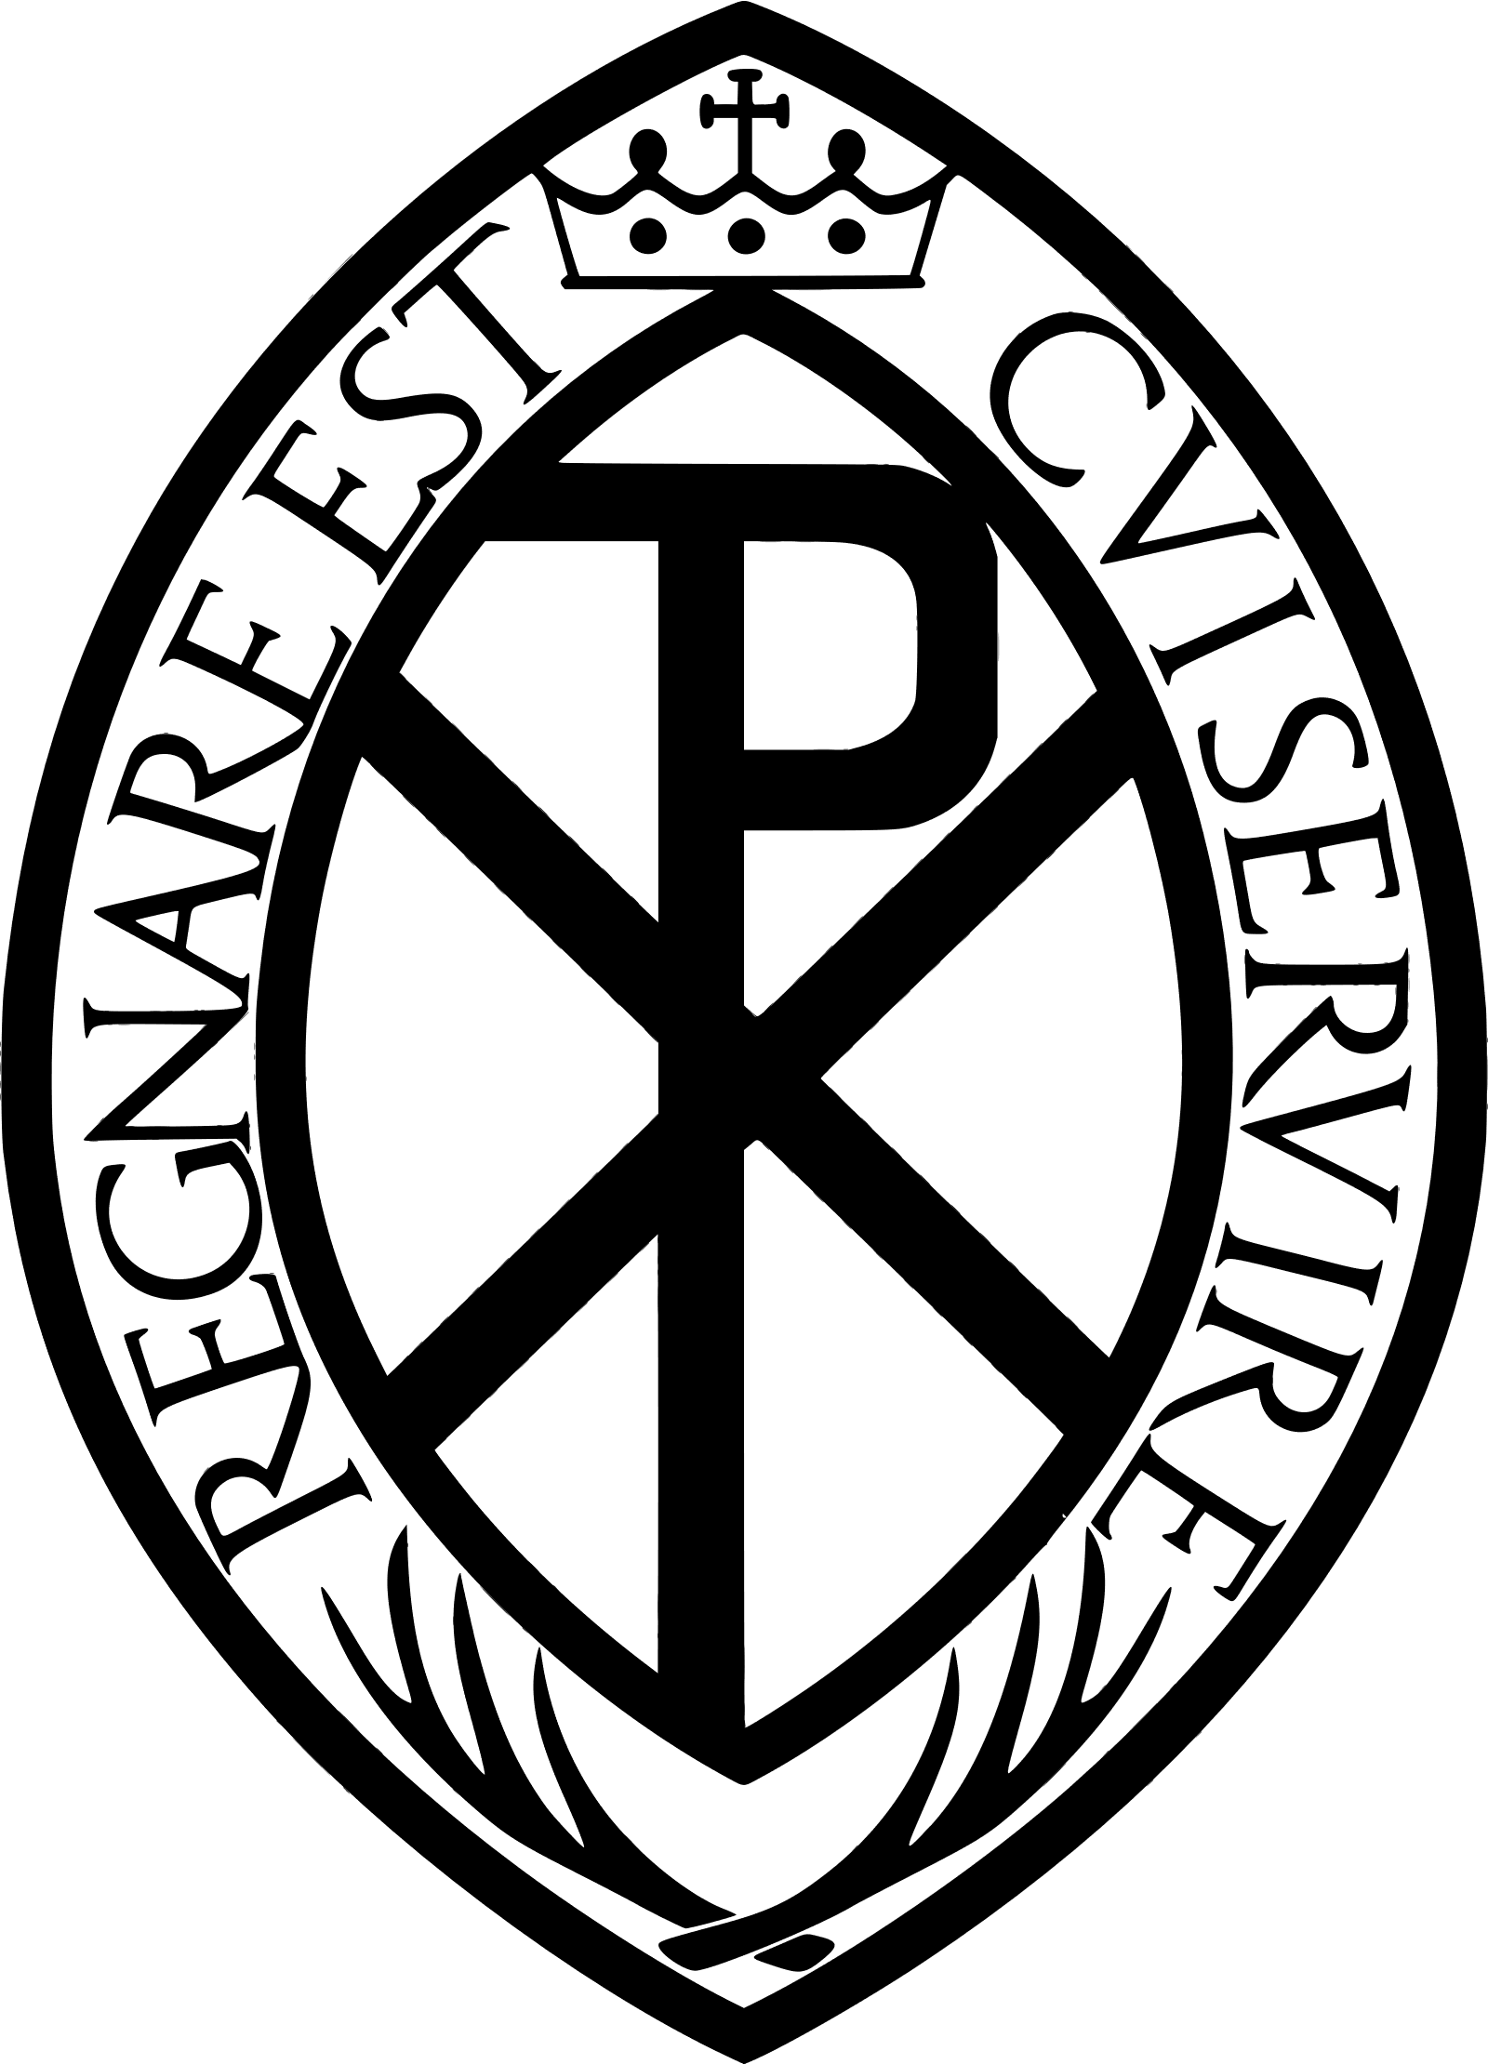

Dear Altar Server,
Thank you for volunteering to become an Altar Server in our parish.
An Altar Server’s job is to help the priest at Mass and other services, without Servers, it is hard for the priest (and the deacon) to celebrate these properly they must try and do everything themselves which takes their concentration away from what they are doing – leading the people in worship.
We also help the other people in church – the congregation, join in the service. People take their cues from the Servers for what they should be doing – standing, sitting, kneeling, saying etc. so it is important we’re always on form, that we behave well and concentrate on what we’re doing.
People come to church to be together, to pray and to worship God, when things don’t go right, the people and the priest might become distracted from what they are doing, we try and make sure this doesn’t happen by knowing want to do and when.
There is a saying, that a good Server is ‘invisible’, this means when things go right, the people should not notice us, we only become ‘visible’ if things start going wrong, which should not happen.
It is important that we stay safe while serving. Always make sure that you listen to the instructions given to you by the adults and older servers. There are many dangers in a church that you won’t find at home or school such as candles, and the Thurible which gets very hot. Always ask if you are not sure what to do.
Take care when moving around church especially when wearing your Cassock or Alb, always pick one that fits you properly, so you don’t trip. Never run in church and never leave church without being picked up by the person you are expecting.
When we serve, we are all friends, we always leave our personal problems and arguments at home. We try and have some fun while remembering that we are doing a serious job.
Altar Servers are members of a world-wide organisation called the Guild of St Stephen. After you have been serving a while and have mastered the basic tasks, and you are sure you want to continue being an Altar Server, the Parish Priest will conduct a short, special ceremony where you and any other new servers will join the Guild. You can then wear the Guild medal like the one shown at the top of this letter. We may occasionally go on trips that the Guild has organised for us where we’ll meet other Servers from around the diocese or the around the country.
There are plenty of jobs for you to try and to get involved with. Some people prefer doing certain jobs and not others, but we ask that you have a go at each one. To keep you safe, there are a few jobs, that we might only let the older or more experienced Servers do.
Always try and arrive in good time, about 10 minutes before the start of a service is best. This gives you time to get changed and to sort out what jobs we’re all going to do.
If you ever need help, ask one of the older servers or the priest or deacon. Don’t worry about making mistakes, we’ve all made them!
Good luck, we’re glad to have you with us!

_________________________ _________________________
Parish Priest Master of Ceremonies (M.C.)

