THE SACRED PASCHAL TRIDUUM
Easter Sunday of the Resurrection of the Lord
The Easter Vigil in the Holy Night
The following is a template for M.C.’s and organisers to adapt as they see fit to help
plan an Ordinary Form celebration of the Easter Vigil.

Before Mass:
- Liturgical Colour is White or Gold
- Processional Cross is on the Sanctuary (it is not carried in the opening procession)
- Charcoal etc. for lighting at the fire
- Candles for congregation, clergy, and servers
- All church lights should be off at the start except those required for safety / emergencies.
- Processional Candles at Offertory Table for Offertory procession (inc. matches). If not used at the offertory, then they are placed in their usual place on the Sanctuary.
- New water ready for the Font
- Jugs to refill the stoops and Font
- Aspergillum (Holy Water bucket and sprinkler)

The Solemn Beginning of the Vigil or Lucernarium

The Blessing of the Fire and Preparation of the Candle
- Procession includes Thurible, Boat, Missal, Stylus, Incense grains and the new Paschal Candle
- Process to from the Sacristy to the place prepared with the Blazing Fire.
- Servers gather safely around the fire.
- Those carrying items should be close to the Priest.

Blessing of the Fire
In the name of the Father, and  of the Son, and of the Holy Spirit  Amen  Dear brethren (brothers and sisters),  on this most sacred night,  … and living with him in God.  Let us pray.  O God, who through your Son  bestowed upon the faithful the fire of your glory  … Through Christ our Lord.  Amen | Missal

Lighting of the Candle
- Server with the Paschal Candle approaches priest  - Stylus handed to Priest; he cuts the candle while saying:  Christ yesterday and today, the Beginning and the End, the Alpha, and the Omega, All time belongs to him, and all the ages, To him be glory and power through every age and for ever. Amen | Paschal Candle
 | Stylus
- Server with incense grains to priest, he inserts them into the candle while saying:  By his holy, and glorious wounds, may Christ the Lord, guard us and protect us. Amen | Incense Grains
- Paschal Candle is lit from the fire  May the light of Christ rising in glory dispel the darkness of our hearts and minds. | Paschal Candle | As above

Procession
- Thurible to fire, Charcoal put in  - Thurible and boat to priest, incense put in  - The Priest / Deacon with candle followed by the Thurible and other Servers lead to the door of church  - The church is in darkness, all lights off except those required for emergencies or safety. | Thurible
 | Boat
- Priest / Deacon stands in the doorway
- Priest / Deacon raises the Paschal Candle
The Light of Christ / Lumen Christi
Thanks be to God / Deo-gratias
- The priest (if he is not the one holding the Paschal Candle, lights his candle)
- Continue processing, stop at the middle of nave.  - Priest / Deacon raises the Paschal Candle  The Light of Christ / Lumen Christi  Thanks be to God / Deo-gratias  - The candles of the congregation are lit | Candle Lighters
- Priest / Deacon stands at the centre top of the steps  The Light of Christ / Lumen Christi  Thanks be to God / Deo-gratias  - All process onto the Sanctuary and stand in places | Thurible and Boat | As above
- Paschal Candle placed in stand
- Thurible and Boat to celebrant.
- The Deacon (if present) receives a blessing from the priest as at the Gospel at Mass.
- Book containing the Exsultet and the Paschal Candle are incensed as at the Gospel at Mass before handing the Thurible back to the Server who returns it to its stand and who then joins the other Servers.

The Easter Proclamation
Exult, let them exult… that I may sing this candle’s perfect praises.
The Lord be with you.
And with your spirit.
Lift up your hearts.
We lift them up to the Lord.
Let us give thanks to the Lord our God.
It is right and just.
It is truly right and just…and lives and reigns for ever and ever.
Amen
Sit, blow out personal candles.

The Liturgy of the Word
- Server with Missal to Chair | Missal
- The Readings follow, nine are provided in the Missal but this is often reduced. You should check which are to be read including any Psalms and if they are to be sung so you are prepared for the next part.  - After each reading there is a prayer. A server with the missal is required each time at the chair. | Note the readings to be read here
- Once all readings and the final prayer are completed the church is in darkness.  - Light ALL candles in and around the Sanctuary.  - Remove any remaining veils. | Candle Lighters
 | Veils
- All Church Lights On | Lights

Gloria
Glory to God in the highest…  - Ring Bells throughout Gloria  …in the glory of God the Father. Amen | Bells

Collect
Let us pray.  O God, who make this most sacred night… for ever and ever. Amen  Sit | Missal | As above

1st reading

Psalm / Gospel Acclamation
- Note that there is only 1 reading and its Psalm. No second reading.  - Incense in Thurible as normal straight after Priest has finished intoning the first Alleluia | Thurible | As above
 | Boat | As above

Gospel
Stand
- Gospel procession forms as normal but without candles
Sit

Homily

Baptismal Liturgy
- This can take several different forms depending on the circumstances each church finds itself in, such as if there are Catechumens to be received into the church, Baptisms, if the font is in a separate place to Sanctuary, or within it, if the font is to be blessed etc. As such we are not going to go into detail here.
- You will find the detail of this parts on pages:
  - Roman Missal: 404-420
  - CTS Sunday Missal: 349-359
- You will likely need Servers for:
  - Carrying the Paschal Candle to / from the Font
  - Book Bearer
  - Holy Water
  - Refilling the stoops
  - Lighting the candles of the congregation
- If removing the lit Paschal Candle from its stand be very aware of the risks / dangers of molten wax falling from its top and how you might accomplish this safely.
- This space is left for you to delete this text and add your own notes.

Universal Prayer (Bidding Prayers)
- The Creed is omitted  - Server to Chair with the Universal Prayers  - From this point forward the Mass continues largely as normal | Universal Prayers

Liturgy of the Eucharist
Sit  - Servers to the back of church for Offertory Procession  - Prepare Altar as normal while above is happening  - Thurible and Boat as normal.  - Presentation of the Gifts, washing of hands as normal | Offertory Procession
 | Prepare Altar
Mass continues as normal | Bells / Gong

Communion Rite
Servers receive communion as usual. | Clear Altar

Concluding Rites

Prayer after Communion
Stand  Pour out on us oh Lord… Though Christ our Lord.  Amen | Missal

Announcements

Solemn Blessing
May almighty God bless you through today’s Easter Solemnity… remain with you forever.  Go forth the Mass has ended, alleluia, alleluia  Thanks be to God alleluia, alleluia! | Missal | As above

Recessional Procession
Normal procession to the Sacristy.  - The Cross and Processional Candles were not carried at the beginning, they are now.  - The Thurible and Boat are not carried. | Processional Cross
 | Processional Candles

Alleluia! Alleluia! Happy Easter!

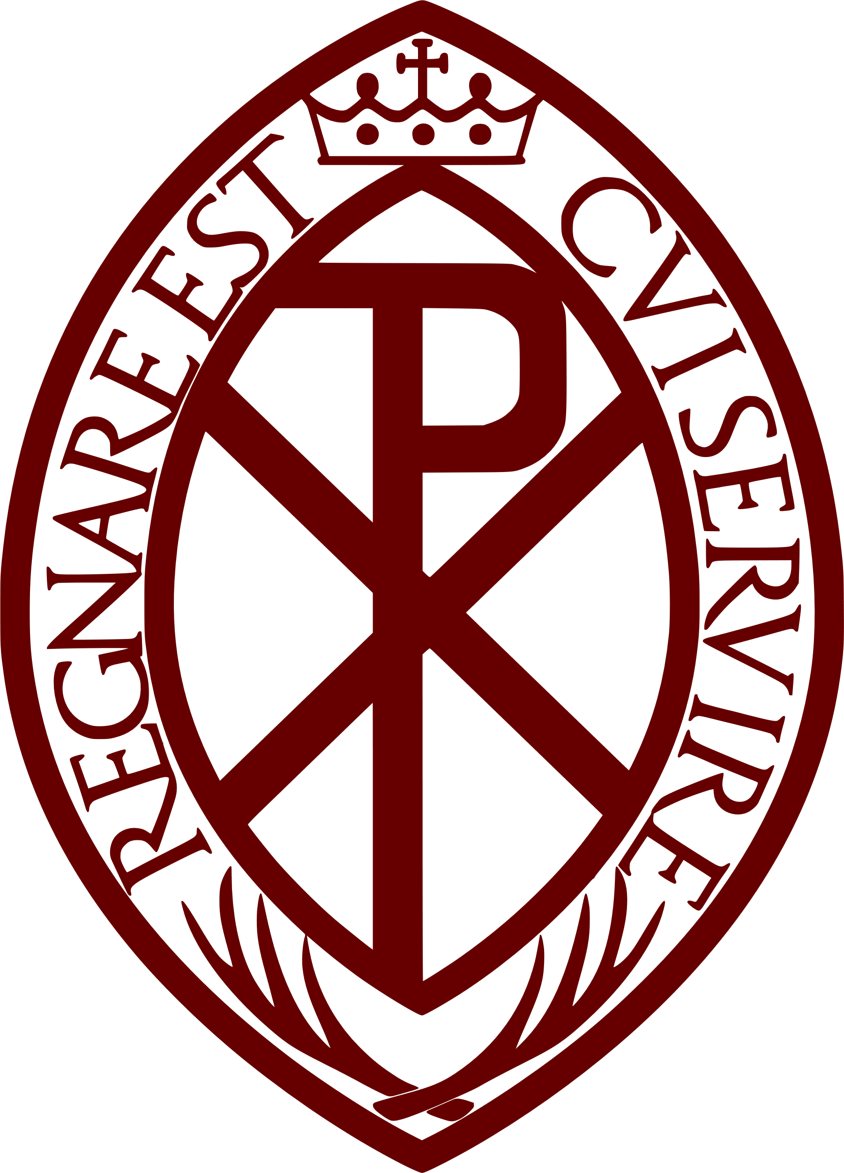
Archconfraternity of St Stephen
guildofststephen.org
facebook.com/GuildofSaintStephen/ | instagram.com/GuildofSaintStephen/ | twitter.com/GuildStStephen

