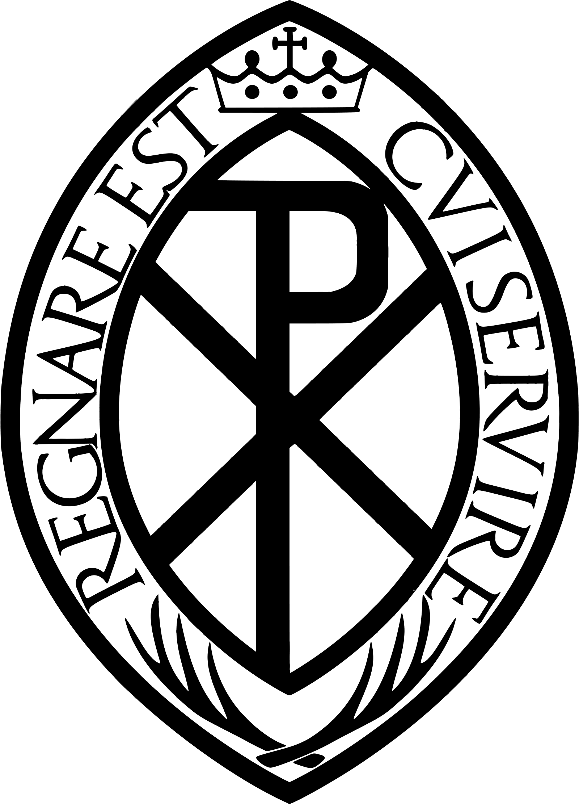 | The Guild Medal

 | At the top is the crown of victory given by God to everyone who overcomes evil, especially those who die for him (like St Stephen and St Thomas More – the Guild patrons).
Around the edge in Latin are the words of the Guild motto:  CVI SERVIRE REGNARE EST, which means, TO SERVE CHRIST IS TO REIGN.  The motto reminds us that if we are faithful to Christ at His altar and in our daily lives, then we are assured of reigning with Him in heaven.  On the reverse is the Latin:  ARCHI SOLDALITAS SANCTI STEPHANI, which means, ARCHCONFRATERNITY OF ST. STEPHEN. |  | 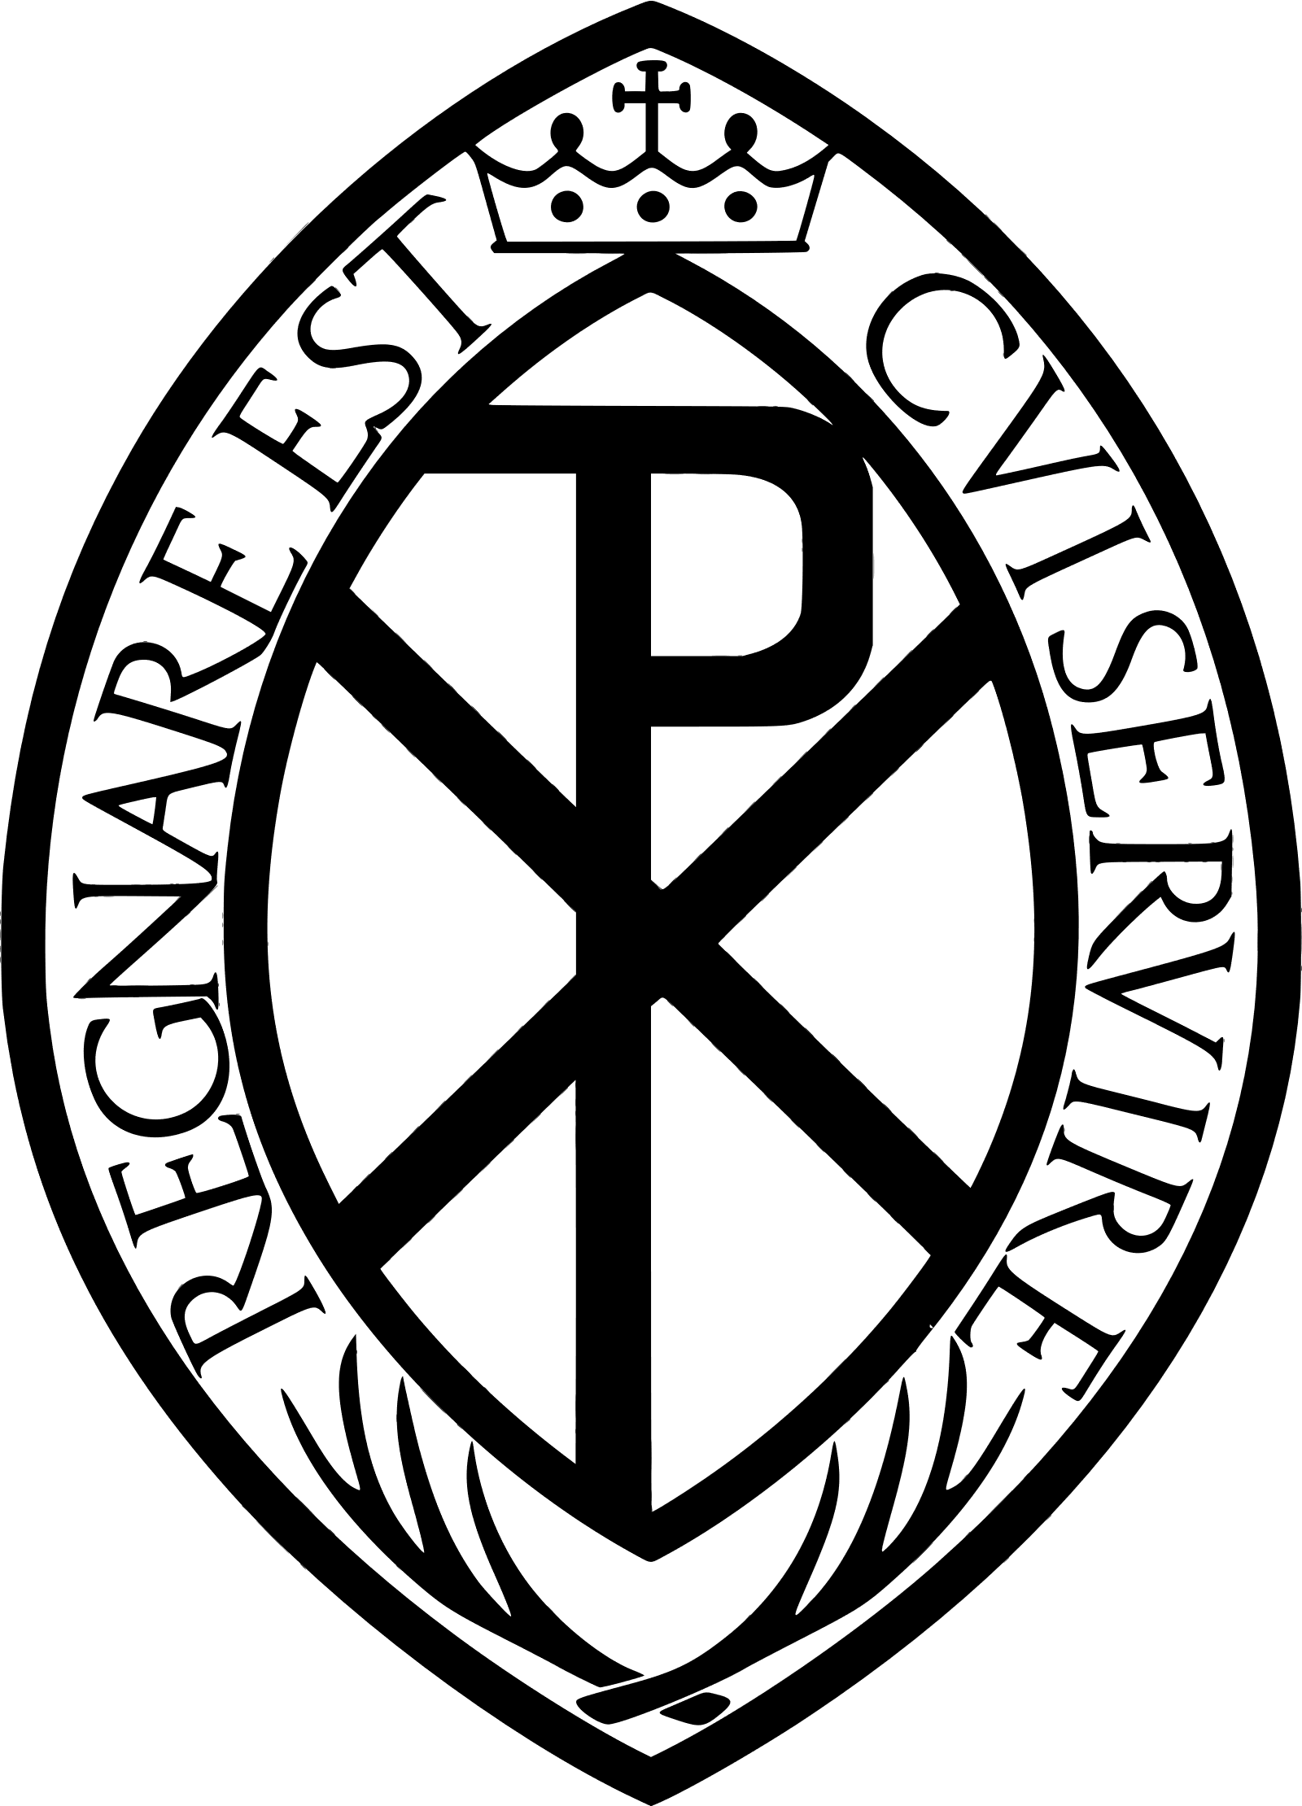
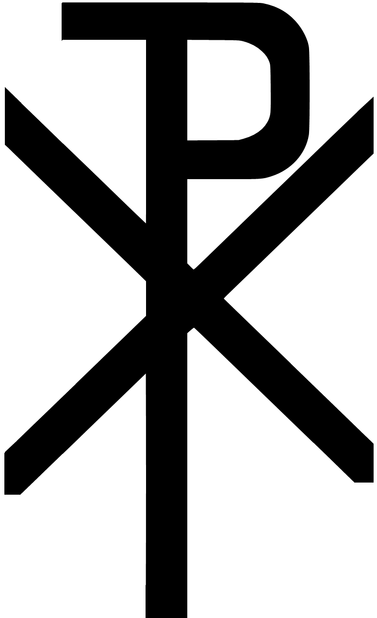 | In the centre is the “Chi Rho”, a Christogram. The letters XP are the first letters of the word “Christ” in Greek ΧΡΙΣΤΟΣ (Christos).  The New Testament of the Bible was originally written in Greek which is why Greek letters are used to represent Christ.  Its position at the centre reminds us that Christ is at the centre of our lives.
 | At the bottom are two crossing palm branches, traditional signs of martyrs – people who died for Christ.
The importance of the colour red

The medal is worn with a red cord, the church uses the colour red as a symbol of the martyrs. The red cord should not be substituted for another colour.

You will see the Priest or Deacon wear red vestments on Palm Sunday and Good Friday, any other days where particular martyrs are remembered (such as St Stephen or St Thomas More) as well at Masses which refer to the Holy Spirit such as Confirmations and Pentecost.

